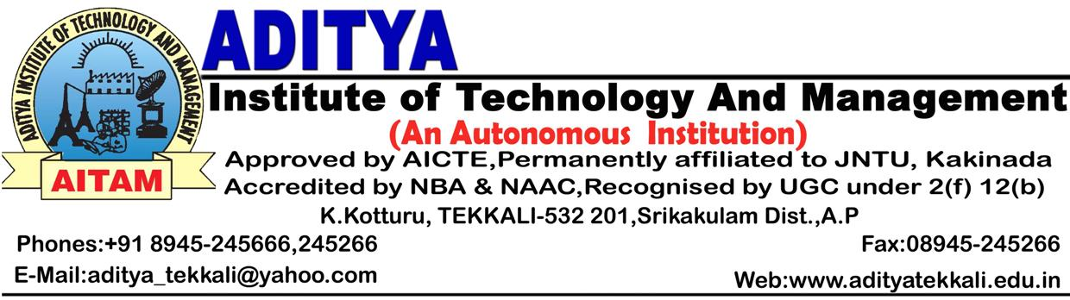 Date : 27.04.2015

C I R C U L A R

The management is pleased to congratulate the following faculty for getting sanctioned minor Research projects recently :

    - Dr.M. Murali
    - Mr.P.V.Muralidhar
    - Mr.D.V.L.N. Sastry
    - Mr.Y.Srinivasa Rao
    - Mr. B.Balaram

It is decided to convene a faculty meeting at 3-00 P.M. on 02.05.2015 in A-Block Seminar Hall for highlighting their achievements by issuing Appreciation incentive cheques (as per current HR Policy) to them.

All the Faculty are instructed to attend the meeting without fail and make it a grand success.



To: All HODs / PG Director – for circulation among
All the faculty.

cc: Principal / Dean – R&D

